2020 Recreation Grant Application

Loretta Morris Fund
Request

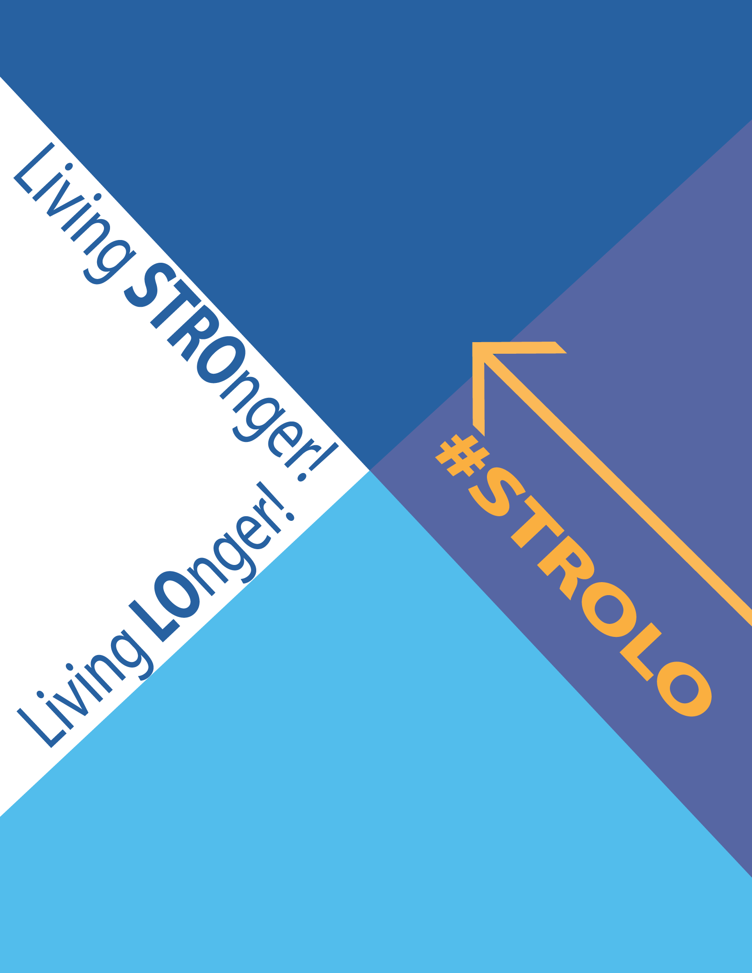
E-mail submission:

Grants@CFLF.org
Subject: (Last Name) Grant application

Mail submission
CFLF
P.O. Box 1344
Burlington, VT 05402-1344

Fax submission:
802.877.2034

CHECKLIST:

Completed Application (All pages of the application must be completed and submitted together)
Photo of applicant doing a physical activity (Digital copy preferred, e-mail to Grants@CFLF.org)
Signed Consent and Contract
CF Care Provider Form (Completed by CF Care Provider)
Letter of reference (Optional)
Copy of application to be kept for personal records (Optional, but highly recommended)

Loretta Morris Memorial Fund Background

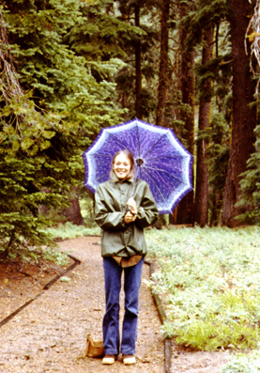
The Loretta Morris Memorial Fund was established in 2010. The Fund was set up by her sister, Barbara Morris Harison with the goal of providing Recreation Grants to help those living with CF enjoy an active lifestyle. Loretta was born March 31, 1950 and died from CF at the age of 21 years. In spite of her illness she enjoyed the recreation activities of horseback riding and dance, and was also an avid reader. She was attending California State University at Northridge at the time of her death.

62 friends and family members have supported the Loretta Morris Memorial Fund. The Memorial Fund has awarded 165 grants since 2010, when the Fund was established with Cystic Fibrosis Lifestyle Foundation (CFLF). The total funds disbursed for the grants equal $75,600.

The youngest Loretta Morris Memorial Fund grant recipient was just nine months old and the oldest recipient was 54 years old. The fund’s primary purpose is to provide grants for recreation activities enjoyed by Loretta and Barbara, i.e. horseback riding, dance, aquatics/swimming, and golf. Grants for other activities are considered and have been awarded. California residents are given preference but grant awards have been made to CF patients from all over the United States.

Comments from grant recipeints demonstrate the benefits of recreation and exercise for healthy lifestyles.

Erick – Age 13 - California - Swimming
“I want to learn to swim to have fun with my family members when they swim. It will also help me with my cystic fibrosis and help me breathe better.”

Lilly – Age 11 - Ohio - Horseback Riding
“Horseback riding is great for me since it exercises my lungs and my spirit. I feel so good riding horses and appreciate your support. Your help gives me a chance to pursue what I love.”

Heidi – Age 4 - North Carolina - Dance
“This grant will allow Heidi to continue with dance on the competitive team with her friends. It has become a big part of her life and provides many things in addition to physical activity like character building.” – Heidi’s Mom

Austin – Age 18 - Kentucky - Golf
“I love playing golf and I always stick to something I enjoy and never give up.”

Grant Application Guidelines

- Due to limited available funding, the CFLF is not able to approve all Recreation Grant requests.

- Loretta Morris Memorial Fund Grant Applications are reviewed on a rolling basis. Please allow 4-6 weeks for processing and review.

- Loretta Morris Memorial Fund Grant requests may not exceed $500.

- CFLF will only consider COMPLETE applications, this includes answering ALL questions AND including a photo. If ANY information is missing, a denial will be made.

- Please check with the establishment where the applicant’s activity will be taking place to make sure they will accept a check from the CFLF as payment for their services.

- Applicants may only submit one type of application at a time.

- Applications MUST be completed by the person with CF. If a child is unable to write the parent or guardian may transcribe for them, but the words must come from the applicant.

- CFLF will pay directly for activities (within six months following the deadline) to the billing activity company or organization. Funds, including reimbursement for past activities, will NOT be paid to the grant recipient.

- Funds may not be requested for the purchase of equipment.

- If an applicant is denied, they may reapply for the same, or different activity, with a new application as soon as they would like.

- Only one Recreation Grant can be awarded per recipient per year.

- We ask that applicants agree to provide feedback during the period of their grant at intake, 12, and 24 months. The “CF Questionnaire” (CFQ-R) is a four-page assessment tool that has been thoroughly studied for reliability and validity. We have received permission to use this tool to assess any effects on the physical, psychological and social quality of life for the grant recipients. Information is used for internal purposes only to demonstrate program impact, and will be kept confidential.

- A Letter of Reference may be included with the application, but it is not mandatory. If one is included, it should be from someone who is familiar with the applicant and with CF. Examples include, CF doctor, nurse, dietician, respiratory therapist, pulmonologist, or social worker.

Loretta Morris Memorial Fund Grant Request
(Please be sure that ALL sections of the application are filled out)

Date: / / 2020

Have you applied for a CFLF Recreation Grant in the past? No Yes
Have you ever received a CFLF Recreation Grant? No Yes

- Household Information: (Optional)
How many people are in your household?
How many in your household have CF?
What is your current annual household income?

Personal Information:

First name: Last name:
Address:
City: State: Zip:
Phone: ( ) (Please cicrle one: Home/Cell/Work)
E-mail: *MUST be an active account
Age: Date of Birth / /

- Emergency Contact:

Name: Relationship:
Address:
Town/State/Zip:
E-mail: Phone: ( )
Can this person be provided with updates and mailings from the CFLF? No Yes

Consent

By signing here I give my permission to the CFLF to discuss my condition with my doctors, other healthcare providers, or other organizations regarding the activities I would like to use my grant towards. I also give persmission to the CFLF to request medical information from my CF healthcare providers including my FEV-1 lung scores. I understand that in compliance with HIPAA regulations the CFLF will keep any of my medically sensitive information confidential.
My signature below is valid for the 24 months following the approval of my Recreation Grant.

Signature:

If under the age of 18:
Parent/Guardian name(s):

Parent/Guardian signature(s):

Activity Request Information

Please be as specific as possible when providing the following information. If any information is mising, or left blank, we will not be able to process your request.

-If more than one activity is being requested please photocopy or print this page mulitple times for each activity. Please remember that the total dollar amount for all activities may not exceed $500.

-You must call or visit the establishment you are requesting funds for, before applying, to make sure they will accept a check from the CFLF as payment.

Type of activity or sport:
(i.e., Gym membership, summer camp, yoga classes, etc.)

Name of business or organization where funds will be paid to:

Address:
Town: State: Zip:
Phone number: ( ) E-mail:
Contact Person (if applicable):

Start date of activity:
(If there is no specific date, write ASAP)

Duration of activity:
(Ex. one year, 6 months, 4 weeks, etc.)

Amount requested: $
(EXACT dollar amount is required, there is a $500 maximum)

Photo Information*

Please describe below where and when the photo you are submitting with your application is from, and the story that describes what we are looking at. (The submitted photo must be recent and clearly show the applicant).
-Please DO NOT fax, staple, tape, glue, or write on photos
-Please do not send headshots or group photos
-Digital copies strongly preferred, please e-mail to Grants@CFLF.org with your name in the subject line

* Please note that photos will not be returned and may be used for publicity purposes

Letter of Reference
(Optional)
Please explain why you chose the person you did to write a letter of reference on your behalf.

(Continue on a separate sheet if necessary)

Essay
How do you feel you will benefit from receiving a Recreation Grant from the CFLF?
Please be as specific and thorough as possible as it will help us to determine eligibility.
(Type on a separate sheet of paper or NEATLY handwrite in the spaces provided).

**For individuals who have received a CFLF Recreation Grant in the past, please tell us about the impact it has had and what impact receiving another grant will have.**

(Continue on a separate sheet if necessary)

Contract of Agreement

Please read and initial EACH of the points below, and upon agreeing to these conditions sign at the bottom of the page.

I understand I am undertaking in the activities requested in this application under
my own (or my child's) risk, and will not hold the Cystic Fibrosis Lifestyle Foundation, nor any of its partners, liable for any injury or negative health impact related to this activity.

I understand the spirit of these funds is to help improve my lifestyle, which
includes my physical, emotional, and social well-being. I will do my best to use this
Recreation Grant to improve my life, and to use it toward on-going activities that I
believe to be benefical to my health.

I will not sell, trade, or profit from any goods or services rendered with this
Recreation Grant.

I understand that the CFLF will contact my CF doctor to review and request
endorsement of the activities requested in this application.

I will do my best to fill out and return the CFQ-R (questionnaires) at intake, 12-months, and again at 24-months to help the CFLF determine the impact on my quality of life from this grant and to help improve the programs of the CFLF.

I will update the CFLF with any address, e-mail, or phone changes.

I give permission to CFLF to utilize my (or my child’s) photographs, parts of my essay, e-mail content, thank you notes, etc. to help demonstrate the impact of this program to the public through the CFLF website, e-mails, mailings, and/or social media. (OPTIONAL)

/ / 2020
Applicant’s Signature Date

/ / 2020
Parent/Guardian Signature (if under 18) Date

*Please contact Program Coordinator, Erin Evans, with questions at: Erin@CFLF.org or (802) 310-3176

* Please fill out the top portion of this page yourself, then have your CF Care Provider fill out the rest of this page and the following page. Pages 9 and 10 MUST be completed and included with your application to be considered for approval.

Applicant’s Name: Applicant’s DOB:
Applicant’s chosen activity:

CF Care Provider (MD, NP, PA) (Page 1)
CFLF Recreation Grant- Request for Information

CF Care Provider’s Name:
CF Care Provider’s E-mail:
CF Care Center:
Center Mailing Address:
City: State: Zip code:

Contact Person: Position:
Phone: ( ) E-mail (required):

Dear CF Care Provider,
We have received an application from the applicant listed above for a Recreation Grant from CFLF. Part of our application review process is to verify with their CF Care Provider their current health status. Any information will be kept confidential and will be used for internal purposes only (i.e., not for research or publication) to better understand and demonstrate program impacts in substantiating ongoing financial support.

The information we would like from you:

- How long have you treated this patient?

- How would you rate their compliance with medications and treatments on a scale of 1-10
(10 being 100% compliant.) Circle one: 1 2 3 4 5 6 7 8 9 10

- Do you endorse their participation in the activity listed above as potentially beneficial to their health?

- Do you have any concerns about their participation in these activities?

- Would you be willing to provide updates of their FEV-1 scores upon request?

As the primary CF Care Provider for the patient listed above, I support and encourage their participation in physical activity as a part of their well-being. I understand that CFLF is not promoting any form of interaction between CF patients, and the funds being applied for are strictly for individual purposes of promoting recreation as an additive measure of airway clearance. I feel that he/she is an excellent candidate to receive a CFLF Recreation Grant.

/ / 2020
CF Care Provider (Signature) Date

CF Care Provider (Page 2)
CFLF Recreation Grant- FEV- 1 Scores

Applicant’s Name: Applicant’s DOB:

Please list the applicant’s FEV-1 scores from the last one to two years, we require a minimum of at least 4 scores. If the patient is too young, or unable to provide lung function scores, please explain:

Please enter FEV-1 data below, starting with the OLDEST and ending with the NEWEST scores. Please use two decimals for the “Score” column.

*Score: Percentile: % Date: / /
*Score: Percentile: % Date: / /
*Score: Percentile: % Date: / /
*Score: Percentile: % Date: / /
Score: Percentile: % Date: / /
Score: Percentile: % Date: / /
Score: Percentile: % Date: / /
Score: Percentile: % Date: / /
Score: Percentile: % Date: / /
Score: Percentile: % Date: / /
*Minimum of four FEV-1 scores required

Other comments:

The scores listed above have been performed and recorded at an affiliated CF Center under supervision of a CF healthcare provider.

/ / 2020
CF Care Provider (Signature) Date

Applicant’s name:

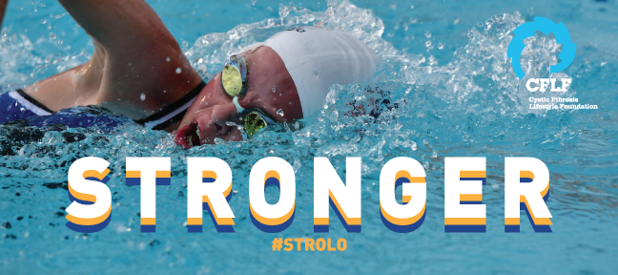

The CFLF is a small, independent non-profit that is not affiliated with, or supported by any other CF organization. The CF Recreation Grant program is made possible by grassroots fundraising events, individual donations, and grants from pharmaceutical companies. The demand for CF Recreation Grants has nearly tripled in the last few years, while the amount of funding available for the program has remained the same.

In order for us to keep up with the demand for grants…
We Need Your Help!

Please consider:
- Making a donation of any amount to the CFLF
- Fundraising for the CFLF
- Telling family and friends about the CF Recreation Grant program
ALSO…
If you know someone who may be interested in donating either one time or on a regular basis, please provide their information below and we will reach out to them.
(This is NOT required in order to be considered for a Recreation Grant).

Name: Relationship to applicant:
Address: Town/State/Zip:
Phone number: ( ) E-mail:

Name: Relationship to applicant:
Address: Town/State/Zip:
Phone number: ( ) E-mail:

Name: Relationship to applicant:
Address: Town/State/Zip:
Phone number: ( ) E-mail:

